# ProtoDummy

By Dominic McNeill - [UNI CODE]

# Table of Contents:

Contents

ProtoDummy 0

Table of Contents: 1

# Design loop 1:

UI to consider are:

* Main menu.
* (optional) Settings.
* Fuel Guage for jetpack.
* Pause Menu.

## Low-fidelity Wireframes:

### Main Menu:

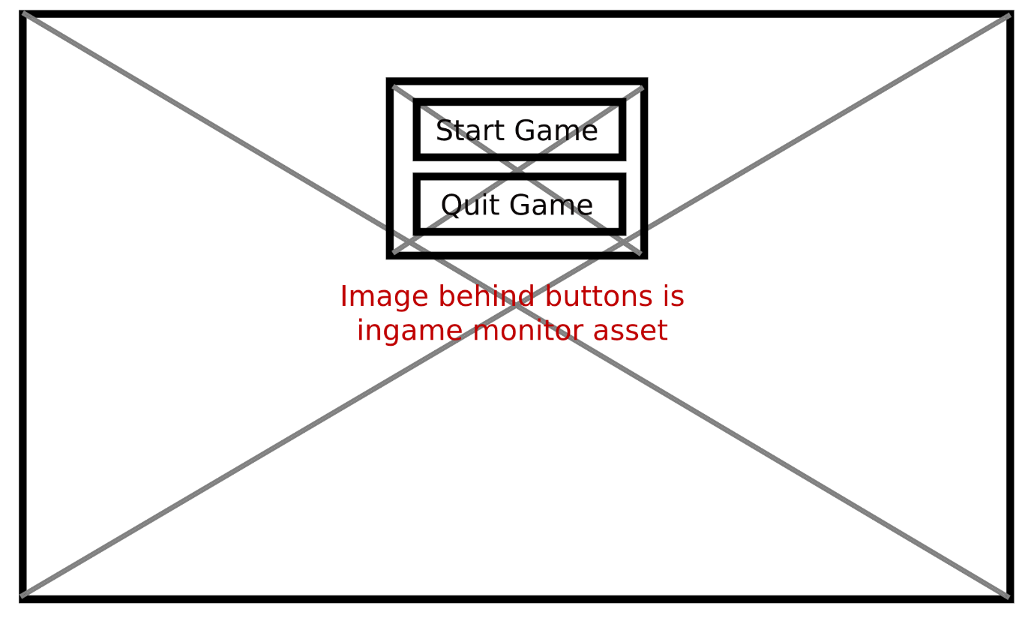

### Pause Menu:

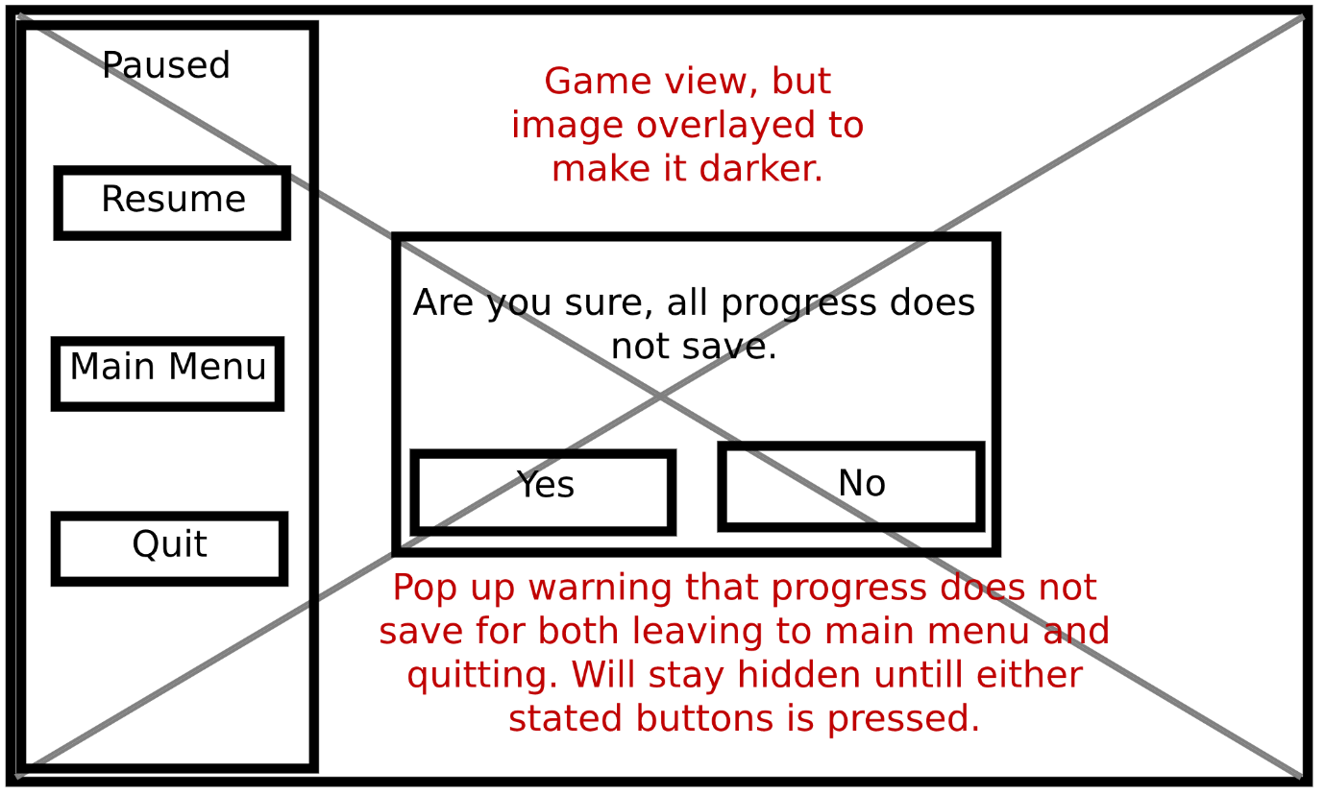

### Jetpack Fuel Guage:

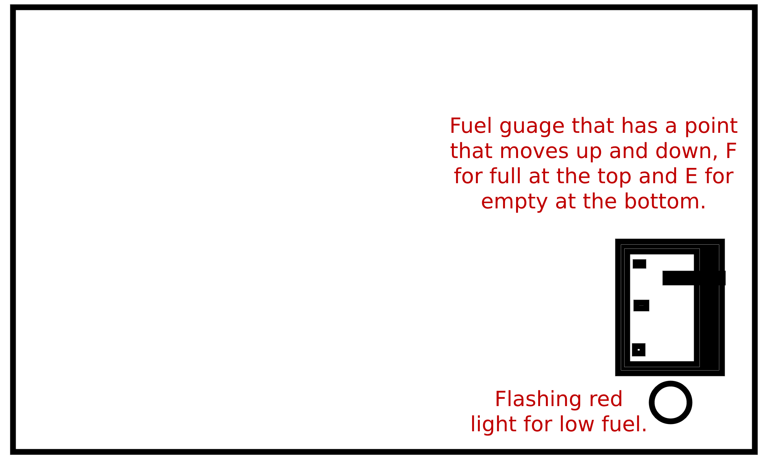

## Testing and test plan: